PROJECT NAME: CHECKER GAME

Roll : 1505097 & 1505100

OVERVIEW FUNCTIONALITY

1. A Server GUI and A Client GUI
2. Server GUI represents all player

And current matches

1. Client GUI represents the main

Game functionality

1. A pawn move indicate by green

Color if it is valid

5. A pawn can have multiple move

If possible

6. A pawn can kill others pawn if

Possible

7. Kill function also enable multiple

Kill

8. There is sound if kill function executes

Successfully

9. If a pawn becomes a king then it able to

Have some special move

HOW TO START

1. First run server.jar from checkergame/dist
2. Then run checkergame.jar from same

Directory.You have to run this file twice.

FUNCTIONALITY WITH PHOTO

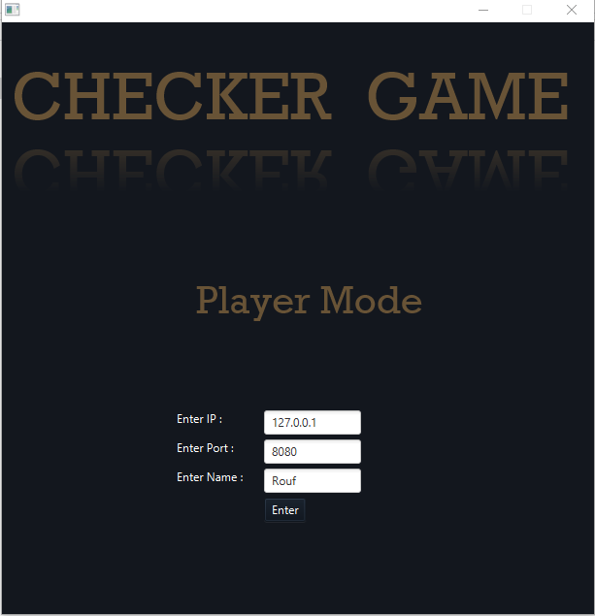

Starting window of Client. You can put your ip, port and name here.

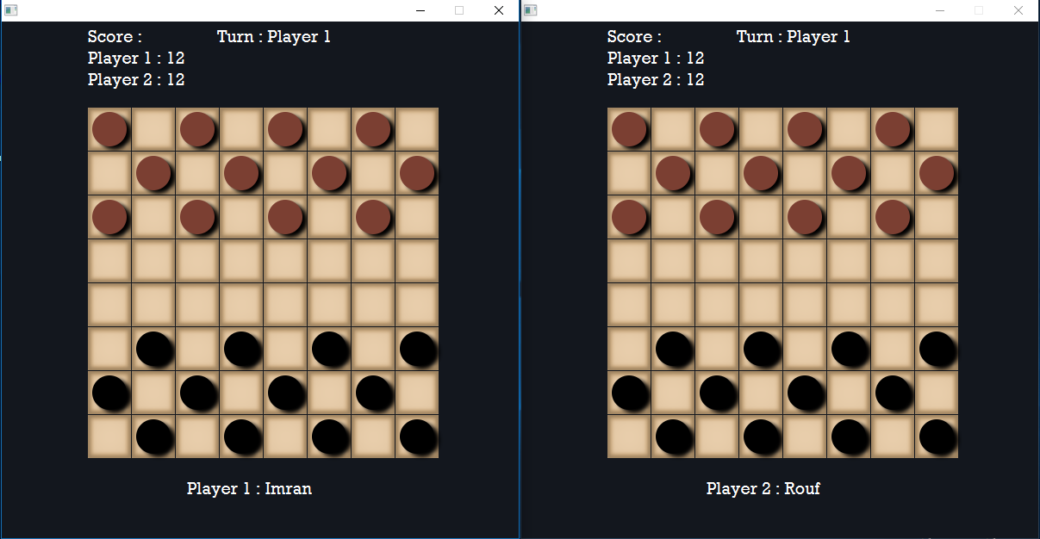

Starting window after enter into the game. Two separate gui for two players.

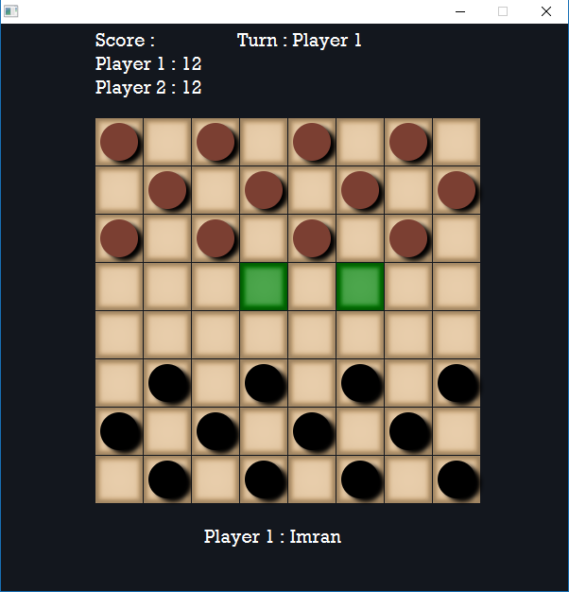

Possible turn of a single pawn (indicating by green color).

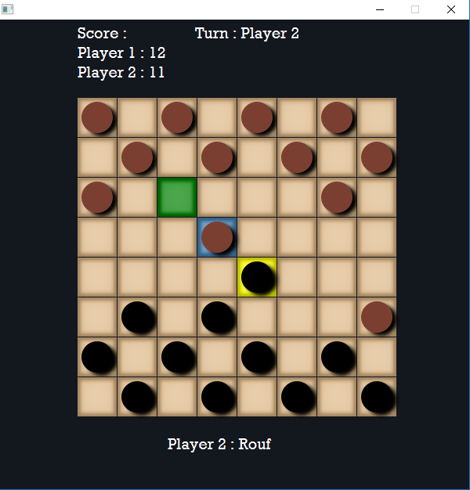

Capturing of a pawn indicating by blue color. Final destination is green.

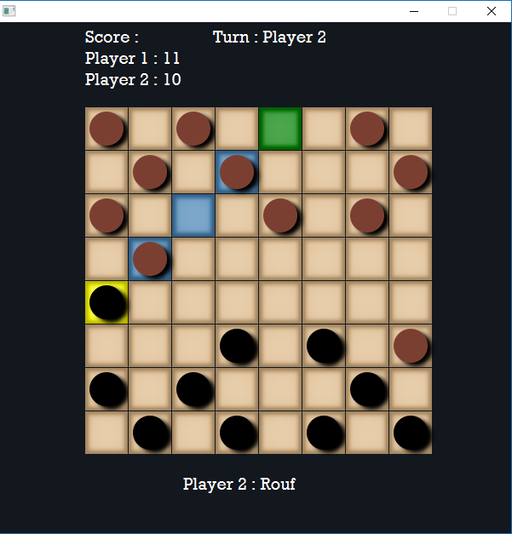

Capturing More than one pawn.

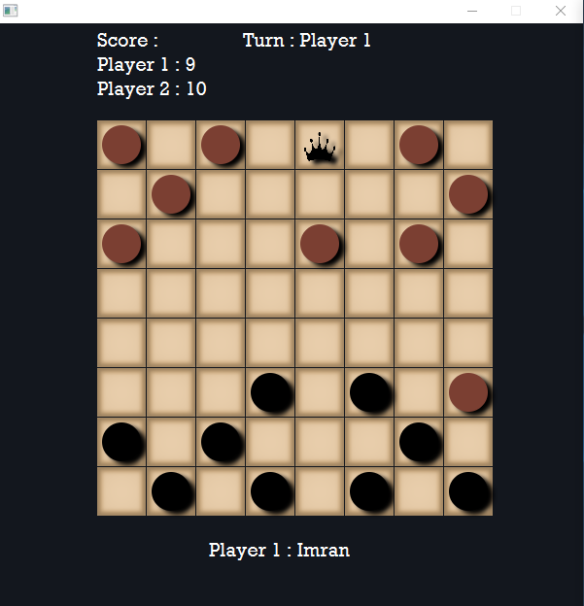

King indicate by black crown.

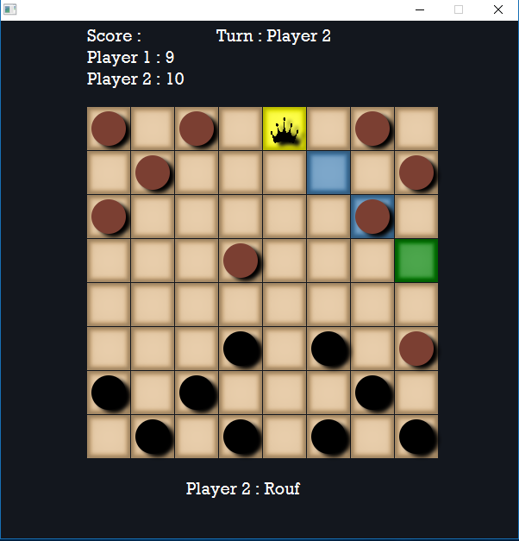

King have capturing or moving diagonally.

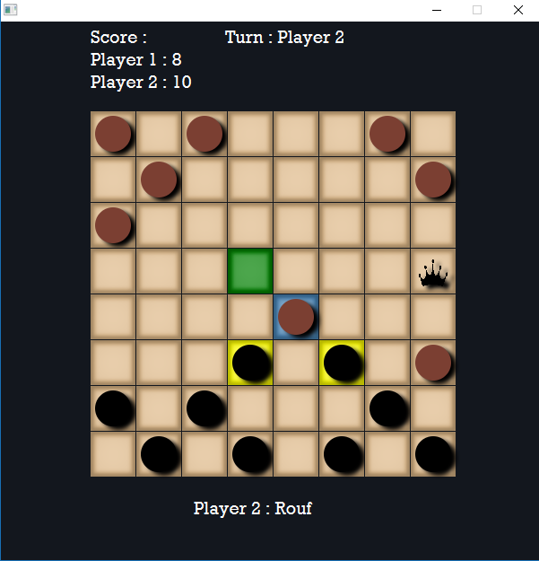

Multiple Capturing.

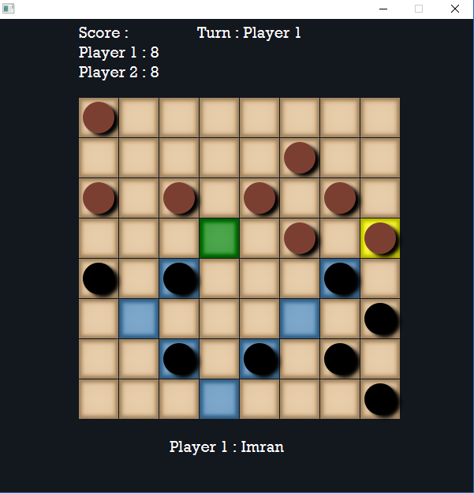

Critical capturing.

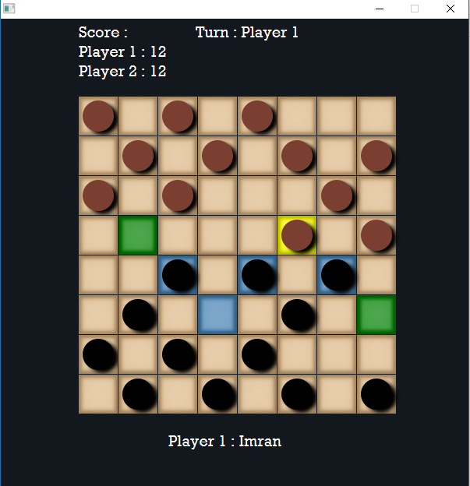

Multiple capturing way.

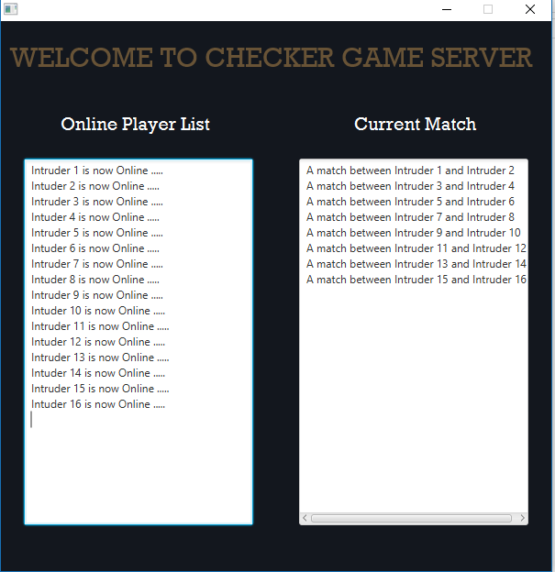

Server GUI.